Task 1: Draw flowcharts for ordering a book.

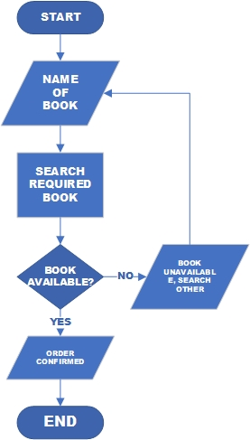

Task No 02: Draw flowcharts for Taking Admission in University.

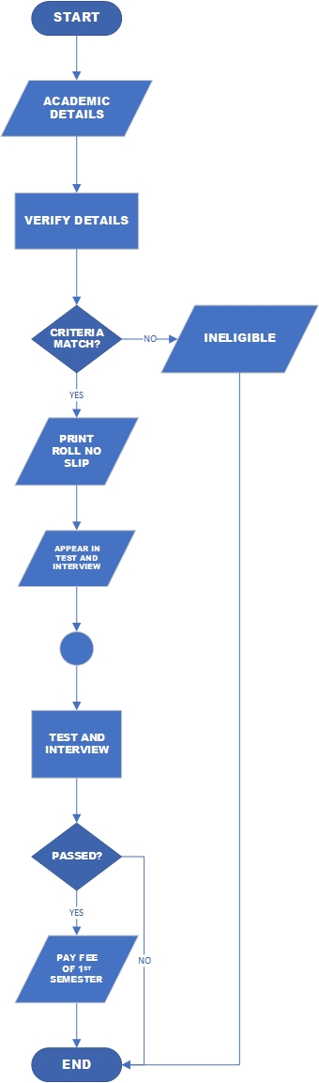

Task No 03: Draw a Flowchart for Fee payment procedure in a University.

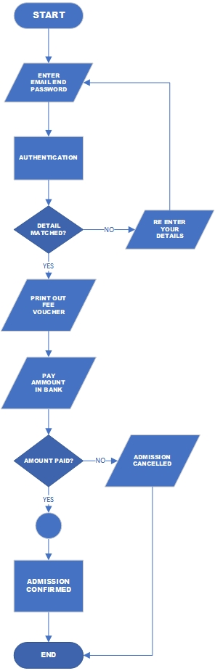

Task No 04: Draw a Flowchart for Reporting a crime in Police Station.

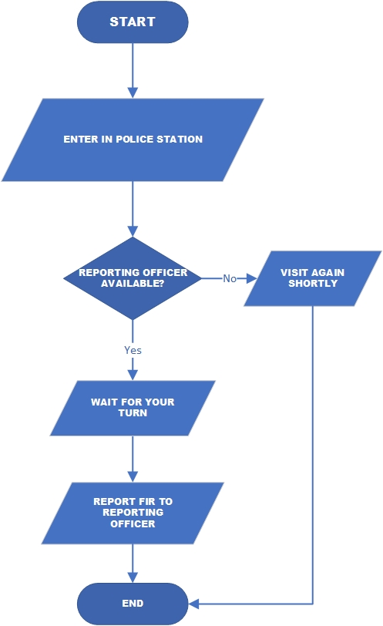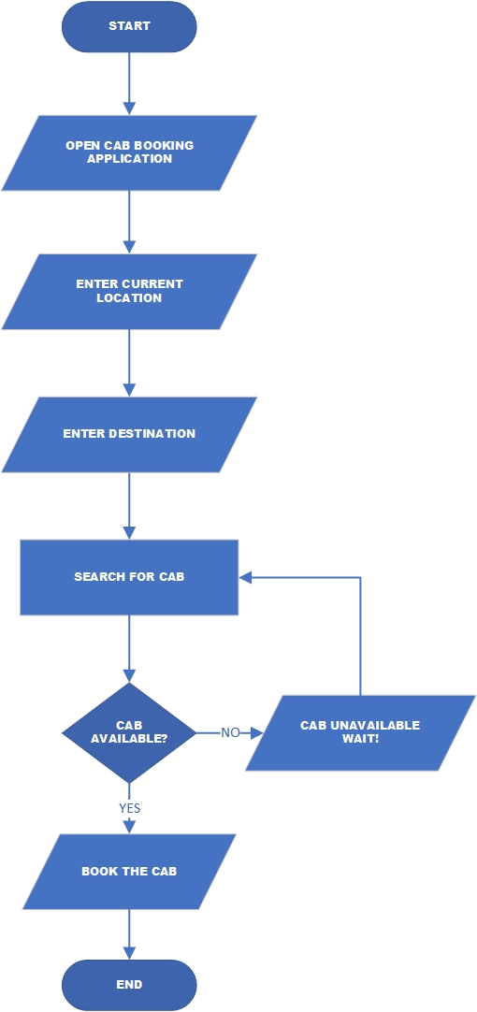Task No 05: Draw a Flowchart for Hiring a Cab.